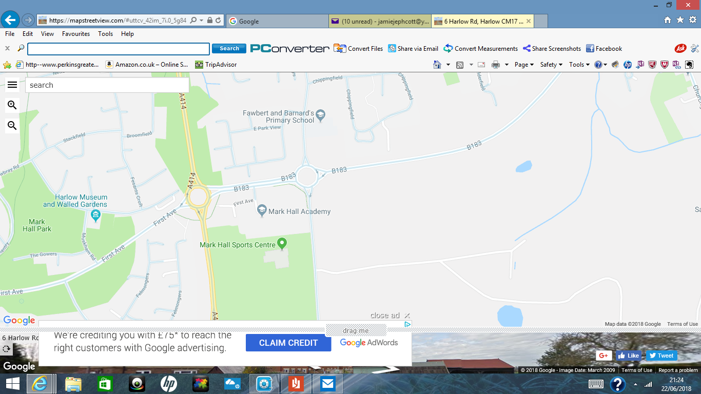

HRC HQ’s

Walk to the start up London RD

Mid week league parking F&B School London RD Harlow CM170DA